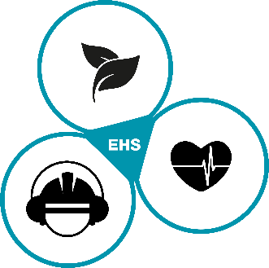
Coronavirus – COVID-19 – Self disclosure

In the context of the current outbreak of the coronavirus (COVID-19), the following self-disclosure must be provided for you. Before entering the premises of the DRÄXLMAIER Group you are obliged to answer the following questions truthfully:

Personal data:

Name and Surname:
Cell-Phone Number:
Email-address:
Accompanying person(s):

Self-disclosure:

- Do you have any of the symptoms of the disease such as fever, cough, shortness of breath and have you had knowingly contact with a confirmed COVID-19 case within the last 14 days?

☐ YES = NO Access ☐ NO = Continue with question 2

- Do you have any of the symptoms of the disease such as fever, cough, shortness of breath and have you had knowingly household-like contact with a person from an international risk area within the last 14 days?

☐ YES = NO Access ☐ NO = Continue with question 3

- Have you spent the last 14 days in a currently designated international risk area?

☐ YES = Continue with question 4 ☐ NO = Access OK

- If you have been in a currently designated international risk area in the last 14 days, when did you return from there?

Date of return: __________________________________________

- Has a PCR test been performed at a state-accredited laboratory at least five days after returning from an international risk area and has it been negative (certificate must be presented)?
- Are there at least 14 days between the date of return from the international risk area and the date of access to the company premises?

☐ One time YES = Access OK ☐ Two times NO = NO Access

Date:___________________ Signature:_________________________________________________

Only for visitors: Personal contact list (DRÄXLMAIER Group)

Name | Surname | Department | Contact duration in min

The personal contact list must be documented during the visit. The completed self-disclosure form must be handed over to the plant security when leaving the company premises. The self-disclosure is kept in paper form for four weeks and destroyed afterwards.

